Great Budworth CE Primary School Pupil Premium Strategy Statement
This statement details our school’s use of pupil premium (and recovery premium for the 2023 to 2024 academic year) funding to help improve the attainment of our disadvantaged pupils.
It outlines our pupil premium strategy, how we intend to spend the funding in this academic year and the effect that last year’s spending of pupil premium had within our school.

School overview
Detail | Data
School name | Great Budworth CE Primary School
Number of pupils in school | 58
Proportion (%) of pupil premium eligible pupils | 16% (9 pupils)
Academic year/years that our current pupil premium strategy plan covers (3 year plans are recommended) | 2022-25
Date this statement was published | 17th November 2022
Date on which it will be reviewed | 17th November 2023
Statement authorised by | R Corradine
Pupil premium lead | R Corradine
Governor / Trustee lead | A Bolshaw
Funding overview
Detail | Amount
Pupil premium funding allocation this academic year | £11.700
Recovery premium funding allocation this academic year | £0
Pupil premium funding carried forward from previous years (enter £0 if not applicable) | £0
Total budget for this academic year  If your school is an academy in a trust that pools this funding, state the amount available to your school this academic year | £11,700

Part A: Pupil premium strategy plan

Statement of intent
For children entitled to free school meals, children in care and children of parents in the armed forces, the school receives the pupil premium grant. Children who are on roll at the annual census who have been entitled to free school meals in the last 6 years will also gain extra funding.
The Pupil Premium provides funding for pupils: • Those who have been in receipt of free school meals (FSM) at any point in the past 6 years (£1300 per child) • Those who have been continuously looked after for the past six months (£1900 per child) • Children whose parents are currently serving in the armed forces (£300 per child)
School vision
Great Budworth CE Primary school has high expectations and aspirations for all pupils, irrespective of their background or the challenges they face, ensuring they make good progress and attainment in all subject areas. Our aim is to empower all of our pupils to achieve their optimum potential in a safe, happy and individually focused school environment. We believe this creates pupils who are confident and well-balanced, and therefore best-placed to thrive. The main focus of the plan is to identify barriers facing pupils to them achieving their potential and to ensure the gap between these pupils and their peers is narrowed and not widened further under the assumption about the impact of disadvantage.
Great Budworth CE Primary school implements high quality teaching with a focus on areas where disadvantaged pupils require the most support. This is proven to have the biggest impact on these pupils and in doing so, also benefits non-disadvantaged pupils in sustaining their progress and attainment. We strive for outcomes (academic and non-academic) to be in line or better with their non-disadvantaged peers and aim to:
- Narrow the gap for those pupils not on track to achieve the expected standard at the end of KS1 and KS2.
- Narrow the gap for those pupils in receipt of EYPP (Early Years Pupil Premium)
- Ensure early identification of additional needs and to promote early and effective intervention programmes.
- Ensure that there is extra support to facilitate emotional and social development in addition to academic support.
- Use academic and local research to make informed choices about the most suitable intervention programmes to use with our children to ensure we are promoting accelerated learning.
In order to achieve this, it is our intention to ensure:
- We provide a rich and varied whole school curriculum that increases pupils’ aspirations and understanding of the value of education and their place within it.
- There is robust diagnostic assessment of our disadvantaged children for academic and non-academic outcomes.
- Following assessments, school leaders will identify who needs which intervention to close any emerging gaps.
- All children in receipt of PP funding will have the same exposure to quality first teaching practices in addition to targeted academic support and wider strategies to develop their cultural capital.
- School leaders build a culture of clear and sustainable implementation, ensuring the deployment of key staff are working with priority children.
- Monitor attendance and persistent absence to ensure attendance of the disadvantage is in line or better than non-disadvantaged pupils.
- Making evidenced informed decisions on what to implement and by whom.
- We will regularly monitor the impact of additional interventions and strategies used – ensuring we adapt any strategies and processes.
The Key principals which underpin this strategy plan are:
- Children can only achieve their potential with consistently high-quality teaching and a curriculum which is meaningful, providing with the skills they need to succeed and to move onto the next stage in their education.
- Cultural capital is the essential knowledge that children need to prepare them for their future success. It is about giving children the best possible start to their early education. By ensuring children in receipt of PPG can access all aspects of the curriculum, including enrichment activities (extra-curricular visits, clubs, music tuition, sports events etc), means they have the same opportunities as all other pupils.
- If children are not in school they cannot make progress and the gaps in learning, and social and emotional development, will inevitably widen. Children develop a work ethic and build resilience through regular attendance at school. If they do not attend regularly then there are implications for applying these skills and values in the workplace.

Challenges

This details the key challenges to achievement that we have identified among our disadvantaged pupils.
Challenge number | Detail of challenge
1 | Our assessments and observations indicate that the education and well-being of many of our disadvantaged pupils have been impacted by partial school closures to a greater extent than for other pupils. These findings are supported by national studies. This has resulted in significant knowledge gaps leading to pupils falling further behind age-related expectations in maths, reading and writing.
2 | Our assessments, observations and discussions with pupils and families have identified social and emotional issues for many pupils, and a lack of enrichment opportunities in particular during school closure. These challenges particularly affect disadvantaged pupils, including their attainment.
3 | We have identified that financial pressures cause additional stress within the home for disadvantaged families (lack of digital devices, unable to pay for school visits, uniform etc)

Intended outcomes
This explains the outcomes we are aiming for by the end of our current strategy plan, and how we will measure whether they have been achieved.
Intended outcome | Success criteria
Pupil premium children achieve outcomes that are in line with non-pupil premium children. | There will be little disparity in the attainment of pupils’ outcomes in the following areas:  GLD in Reception  Year 1 Phonics Screening  End of KS1 judgements  Multiplication checker in Year 4  KS2 SATS 23-24
All pupil premium children below ARE make accelerated progress in all areas | Accelerated progress in reading and writing.  Read write Inc.  Fresh Start  KS2 Reading and Writing outcomes in 2023/24 show an increase
Quality first teaching  Creative approach to ensure ‘sticky knowledge.’ | Maths - White Rose  English – Pathways to write  Staff will have taught thematically across the curriculum evident in planning and books.
Opportunities for enrichment and wider curriculum | Forest Schools  Day trips  After school clubs  Residentials with financial support.
Targeted intervention support | ELSA Small group intervention support  CPD in Trauma informed Practice

Activity in this academic year
This details how we intend to spend our pupil premium (and recovery premium funding) this academic year to address the challenges listed above.

Teaching (for example, CPD, recruitment and retention)
Budgeted cost: £4000
Activity | Evidence that supports this approach | Challenge number(s) addressed
Read Write Inc training | Evidence consistently shows the positive impact that targeted academic support can have, including on those who are not making good progress across the spectrum of achievement. Considering how classroom teachers and teaching assistants can provide targeted academic support, including how to link structured one-to-one or small group intervention to classroom teaching, is likely to be a key component of an effective Pupil Premium strategy. The EEF guide to pupil premium | 1
Forest School Sessions with qualified Forest School teacher. | The evidence in the toolkit is primarily focused on academic outcomes. There is a wider evidence base indicating that outdoor adventure learning may have positive impacts on other outcomes such as self-efficacy, motivation and teamwork. Outdoor adventure learning may play an important role in the wider school experience, regardless of any impact on academic outcomes. (Sutton Trust EEF PP toolkit.) | 1, 2
Pastoral support from Family Support Worker for vulnerable children and families- key support needed to ensure attendance and readiness to learn is maintained. | EEF Guidance about Wider strategies focusing on: SEL, Well-being and Mental Health. | 2
Training and deployment of staff member to deliver ELSA programme | Although SEL interventions are almost always perceived to improve emotional or attitudinal outcomes, not all interventions are equally effective at raising attainment. Improvements appear more likely when SEL approaches are embedded into routine educational practices and supported by professional development and training for staff. Sutton Trust EEF PP toolkit | 2

Targeted academic support (for example, tutoring, one-to-one support structured interventions)
Budgeted cost: £4000
Activity | Evidence that supports this approach | Challenge number(s) addressed
Read write inc 1:1 catch up | The evaluators found some evidence that pupils eligible for free school meals (FSM) responded particularly well to Read Write Inc. Phonics and made, on average, three months more progress than pupils who were not offered the programme. EEF independent evaluation of RWI and Fresh Start | 1
Read Write Inc Fresh Start | There is a large body of evidence, including in the Teaching and Learning Toolkit, that suggests that systematic synthetic phonics approaches have a positive impact on the development of early reading skills… EEF independent evaluation of RWI and Fresh Start | 1

Wider strategies (for example, related to attendance, behaviour, wellbeing)
Budgeted cost: £3700
Activity | Evidence that supports this approach | Challenge number(s) addressed
B Tales and arts enrichment activities | Arts participation approaches can have a positive impact on academic outcomes in other areas of the curriculum. Wider benefits such as more positive attitudes to learning and increased well-being have also consistently been reported. EEF PP Toolkit | 3
Art Therapy Sessions | Arts participation approaches can have a positive impact on academic outcomes in other areas of the curriculum. Wider benefits such as more positive attitudes to learning and increased well-being have also consistently been reported. EEF PP Toolkit
Outdoor learning | The evidence in the toolkit is primarily focused on academic outcomes. There is a wider evidence base indicating that outdoor adventure learning may have positive impacts on other outcomes such as self-efficacy, motivation and teamwork. Outdoor adventure learning may play an important role in the wider school experience, regardless of any impact on academic outcomes. Sutton Trust EEF PP toolkit. | 3
School Visits including residentials | Outdoor Adventure Learning might provide opportunities for disadvantaged pupils to participate in activities that they otherwise might not be able to access. Through participation in these challenging physical and emotional activities, outdoor adventure learning interventions can support pupils to develop non-cognitive skills such as resilience, self-confidence and motivation. | 2, 3
After School Clubs at school | In addition to providing academic support, some school programmes aim to provide stimulating environments and activities or develop additional personal and social skills. These programmes are more likely to have an impact on attainment than those that are solely academic in focus. | 1, 2, 3
Holiday Camps at school particularly for disadvantaged pupils. | Studies indicate that attendance and drop out are key challenges for voluntary, out-of-term time provision, To overcome these issues, schools should aim to identify any potential barriers (such as food or transport costs, clashes with planned holidays or religious events) early on, such as through communication with parents/carers to improve engagement. Including additional non-academic activities such as sports, arts or cultural enrichment are valuable in their own right and can offer opportunities to pupils from low income households who may not otherwise be able to afford them. | 2, 3

Total budgeted cost: £ 11700]

Part B: Review of outcomes in the previous academic year

Pupil premium strategy outcomes

IMPACT OF 2020/21 Pupil Premium Strategy
Due to COVID-19, performance measures have not been published for 2020 to 2021, and 2020 to 2021 results will not be used to hold schools to account.
Impact of ELSA support adult to work with vulnerable children: ELSA is a training course aimed at teaching assistants in schools. Examples of activities covered on the course are: social skills, recognising and managing emotions, bereavement, social stories and therapeutic stories, anger management, self-esteem, counselling skills such as solution focused and friendship. During 2020-21 our trained ELSA worked with staff to identify and support children facing difficulties in these areas. Through planned weekly interventions the ELSA sessions supported children towards making progress in these areas.

Impact of leadership and management time: Surveys show that pupils feel valued as individuals and are encouraged in their learning, growth and social development in a healthy and safe environment. Accessible and supportive contact for all pupils, issues and barriers to learning are addressed. Effective links with parents/carers. Strong links with community agencies, for example, School Health, EWO, CAHMS, Educational Psychology and Social Care facilitates an integrated approach.

IMPACT OF 2022/23 Pupil Premium Strategy
Outcome 1
- Pupil premium children achieve outcomes that are in line with non-pupil premium children. Summary of attainment of PP children at the end of academic year 2022-2023
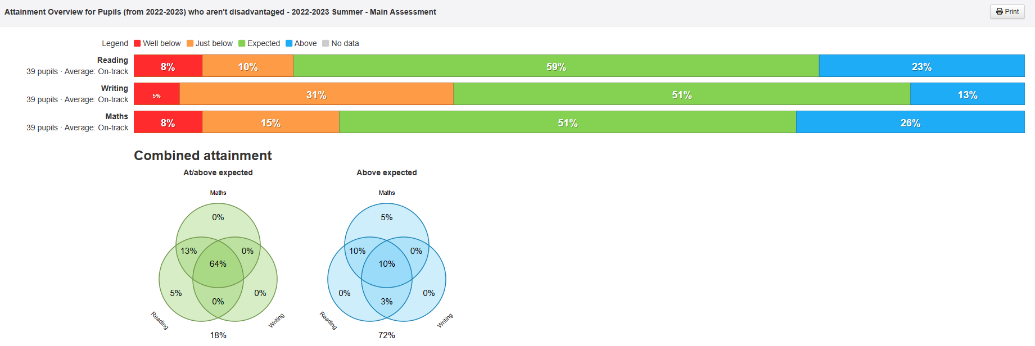
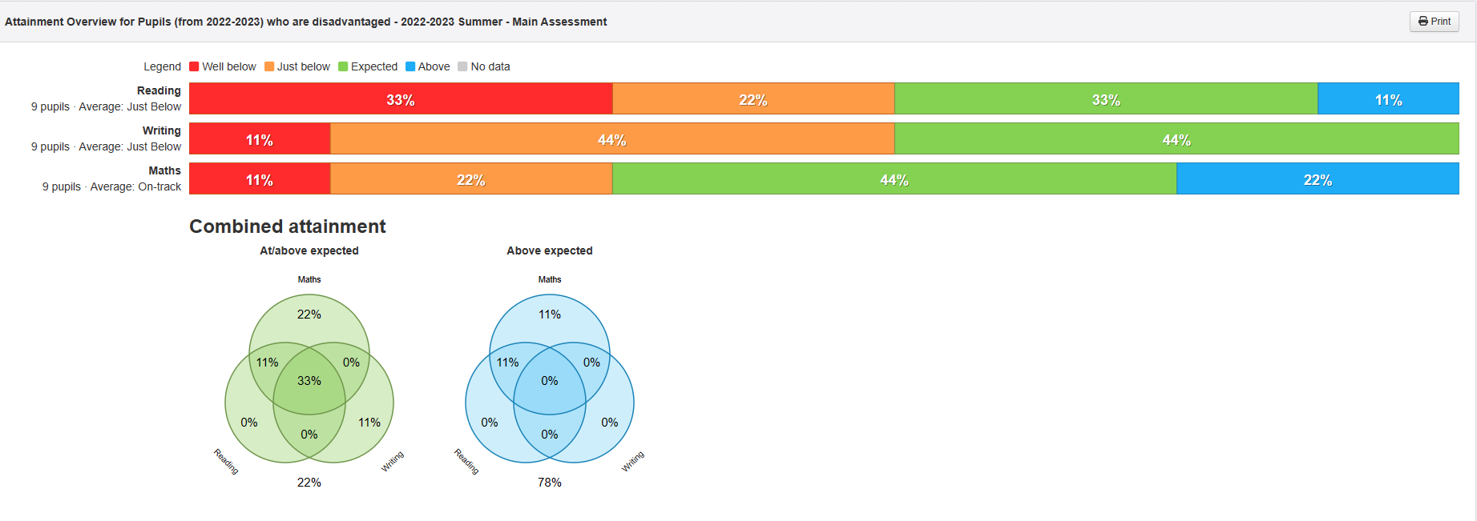

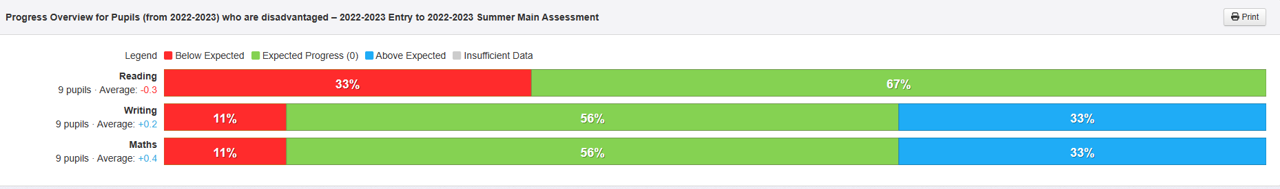
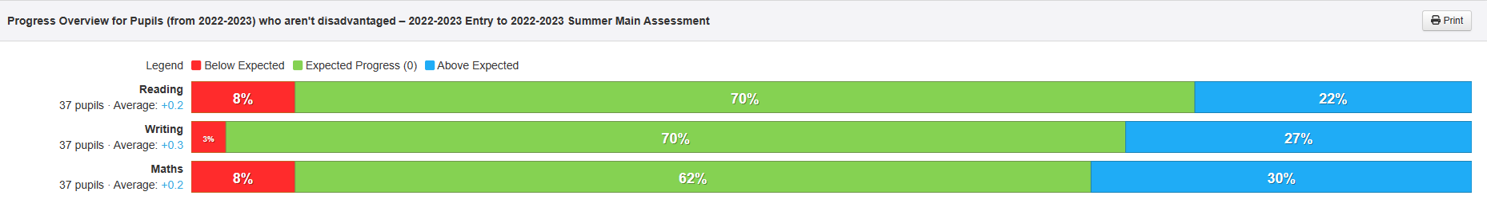

Next Steps:
- Continue to focus on this outcome in order to increase percentages of PP children achieving at least Age-Related Expectations. Outcome to roll over into Academic Year 2023 – 2024
Outcome 2 All pupil premium children below ARE make accelerated progress in all areas Summary of progress of PP children over the academic year 2022 – 2023
Next Steps: • The above shows that most PP children make expected progress but there is not much evidence of accelerated progress. Outcome to roll over into Academic Year 2023 – 2024

Outcomes 3 – 5 While progress against these outcomes is less quantifiable through the use of hard data, it is demonstrable that PP children all benefit from high quality teaching with a focus on retaining learning, as well as opportunities for enrichment activities and targeted intervention support as and when needed.

Externally provided programmes
Please include the names of any non-DfE programmes that you purchased in the previous academic year. This will help the Department for Education identify which ones are popular in England
Programme | Provider
 | NA

Service pupil premium funding (optional)
For schools that receive this funding, you may wish to provide the following information:
Measure | Details
How did you spend your service pupil premium allocation last academic year? | NA
What was the impact of that spending on service pupil premium eligible pupils? | NA

