The Federation of Antrobus St Mark’s and Great Budworth Primary Schools
Great Budworth

For I know the plans I have for you,” declares the Lord,
“plans to prosper you and not to harm you,
plans to give you hope and a future. Jeremiah 29:11

Welcome Back
Happy New Year! I hope everyone was able to enjoy a restful holiday with their families. We have planned an exciting Spring term ahead of us and I was reminded of the quote from the Bible (see above). Knowing we have a plan set out before us under the guiding hand and love of God, gives us such hope and encouragement for the new year ahead. If I can help you in any way, please do contact me via email or on the gate in the morning or if you’d just like to say a quick good morning that’s fine too. I hope to be as accessible and as informative as I can as we work together to educate and nurture your child within our Great Budworth school family.
It has been an exciting start back and has been fantastic to see how well the children have settled into their learning following the Christmas holidays. On behalf of all of the staff team I would like to thank you for all of your kind cards and generous gifts. I am looking forward to watching your children flourish both in their gaining of knowledge and the way in which they interact with themselves and consider the world around them.
Our school theme, this half term, considers Who is my Neighbour? We will be looking at our own school community, our village community and our place within the global community. We will be looking at the lives of refugees, whether it be through the eyes of Mary and Joseph fleeing to safety in Egypt from King Herod’s cruelty, an evacuee from World War II, a fictional character or a child displaced due to war or being outcast due to their ethnicity or beliefs. Our Literacy texts this term consider the Christian values of empathy, courage and kindness alongside our British values of equality and tolerance and mutual respect.
Attendance Matters  Regular attendance at school is very important for children to achieve the best they can. If children are absent from school, it not only affects their education but it also has a negative impact on them both socially and emotionally.  School tries to make sure that all our children attend every day. However, we cannot do this alone and need your help, as parents, to ensure your child has the best possible attendance they can.  Please note that I am unable to authorise absences for holidays taken outside of school holiday dates.  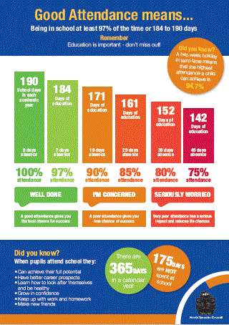  Please note the changes to October half term on the school holiday dates which CWAC changed to fall in line with other local schools. If this affects you please come and speak to me. | After School Clubs  Our enrichment curriculum for this half term is as follows:  Monday Knitting club  Tuesday Mindful Colouring  Wednesday Drama  Card games Club  Thursday Y6 SATs Booster  Lego Club  Friday Film club  Apart from Drama club (see separate email) and SATs booster, after school clubs will be charged at £4.00 per session.  Sign up details will be sent out on School Spider today. Clubs start next week, January 8th. There are no clubs in the last week, 12th February.
Our collective Worship this half term is based on ‘People Jesus meets’. The Christian Values we will be exploring this half term are Hope, Wisdom, Dignity, Community, Joy and Peace.  Children who are noticed for living out the Christian Value of the week, will be presented with one of our new ‘Values Award’ postcards in our family collective worship on a Friday. This is an open invitation for you to join us in celebrating the achievements of the week. We start just after 9:00am and finish no later than 9:30 am. It would be great to see you if you can stay after drop off and have a complimentary cuppa before the worship. | Please see an online safety parents’ information uploaded onto the school website. For more information on this please visit thinkuknow.co.uk
The Children’s Society
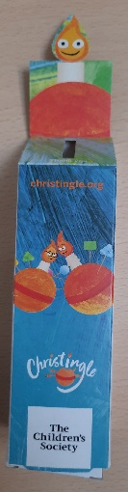

Don’t forget to return
your collection box to
school by
Friday 12th January

FOTS
Bags to School
"It is time to sort your old clothes ready to be recycled, and raise money for school at the same time".
The bags for school will be collecting on Thursday January 25^{th.} Bags to be dropped off at school on the morning of the 25th only please. Please see note below on what they will accept.

Fundraising through December:

The nativity/carol service raffles raised £127.82
Carol Service £71.28
Elf Dash raised £425.61
Christmas Fair £984.28
Wreath Making 917.71
A grand total of £2526.70 which is fantastic!
Thank you to everyone who contributed to these events you have been amazingly generous with your support.

As a huge thank you, FOTS will be holding a FREE film night, at school,
on Thursday 18th January.

Dates for your Diaries
Tuesday 9th January | Forest Schools will restart with Mr Holland each Tuesday for this first half term. Please ensure pupils come to school dressed  appropriately for being outdoors in all weathers.
Wednesday 10th January | Class 3 Residential Meeting for Parents  3:00pm
Wednesday 17th January | Sports hall athletics tournament  Class 3 pupils
Thursday 18th January | Free FoTS Film Night  All Pupils  3:15 -5:30pm
Monday 22nd January | Woodland Trust Tree Planting  Class 3 pupils
Thursday 25th January | Chester Zoo  Whole school Visit
Friday 2nd February | NSPCC Number Day  Whole school, bring in £1, ‘Dress in digits’
Mon 5th – Wed 7th February | Class 3 Residential – Conway Centre  Class 3 pupils
Thursday 8th February | Chinese New Year Special Lunch
Tuesday 13th February | Great Budworth Open Morning  9:30 – 12:00  Please contact the office if you would be able to help us  distribute leaflets to local businesses, tots’ groups, nurseries and homes.  Please do help us to spread the word about our wonderful little school.
Wednesday 14th February | Valentine’s Day Special Lunch
Thursday 15th February | FoTS Valentine’s Disco  5:00 - 6:30pm
Friday 16th February | School Closes for Half term
Monday 26th February | School re-opens
Thursday 7th March | World Book Day  This year our school theme is based on  ‘Read Your Way’  Come to school dressed in your PJs, bring in and share your favourite bedtime story book.  Take a photograph of you reading in your way,  wherever you like to read and how.  Bring it into school to help us make a collage of  Great Budworth’s ‘Extreme Readers’  Stuck for ideas? Click on the link below to find recommended reads and the top 25 picture books and books by age group.  Reading Recommendations (worldbookday.com)
Thursday 14th March | B -Tales Easter Journey  Whole School
Wednesday 20th March | Class 3 Visit to Stockport Air Raid Shelter  (Letter to follow)
Thursday 21st March | FoTS Easter Bingo  (Time TBC)
Thursday 28th March | Easter Service  (Time TBC)
Thursday 28th March School closes for Easter Break.
School Re-opens on Monday 15th April 2024

